

-2026)
V Deepak
2520030503
CSE
C0 -2 Multiway Trees & Range Query Structures

Case Study Topic : Tour Plan Hotel Price Range Query using B+ Tree

Work Done Summary
In this case study, we implemented a B+ Tree for the Tour Plan Smart Tourism & Travel Itinerary Optimization System. The B+ Tree stores hotel prices in sorted order and allows users to perform efficient range searches. The system quickly retrieves hotels whose prices fall within a selected range, making tourism planning faster and more convenient.

Implementation Details

Inserted ticket prices into the B+ Tree structure.

Maintained sorted order using multiway tree balancing.

Performed range queries on ticket prices.

Retrieved ticket details quickly for selected ranges.

Improved database indexing and searching efficiency.

Result Screenshot/Output
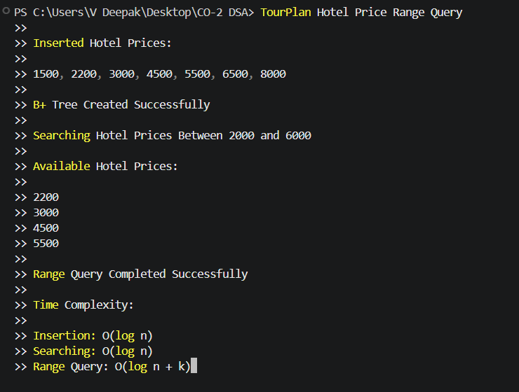
The B+ Tree provided efficient indexing and range query operations for the TourPlan tourism management system.
Hotel records were retrieved quickly within the selected price ranges, helping tourists find suitable accommodation options efficiently.
Compared to Binary Search Trees, B+ Trees performed better for large tourism databases because all data entries are linked sequentially, enabling faster traversal and improved range query performance.
GitHub Link:

